# Control Center Frontend/Backend Deployment

* Shepherd Frontend
  + 1. Open the Cloud Console Plugin Page for Ads Shepherd
  + 2. Trigger a build
  + 3. Deploy the new build (Production or Preprod)
  + 4. Verify the deployment result
* Shepherd Backend (API & Worker)
  + Note: the order of Shepherd backend deployment is worker, beat (if needed) and api.
  + 1. Build your image via Jenkins (Prod or Preprod)
  + 2. Verify the image is pushed to the hub
  + 3. Deploy the image via Cloud Console
  + 4. Start "Dry run" and "Submit"
    - How to remove a worker
  + 5. Check if new features are working or not
* Shepherd Backend (Beat)
  + How to deploy one Beat on cluster 37
* Deployment on Staging Env to test from unmerged branches
  + 1. Purpose and Preparation
  + 2. Frontend Deployment for Staging
  + 3. Backend Deployment for Staging
    - Build your image
    - Deploy at Worker
    - Deploy at Beat
    - Deploy at Api
  + 4. Testing at Staging
* Update and Send Release Information

# Shepherd Frontend

## 1. Open the Cloud Console Plugin Page for Ads Shepherd

* <https://cloud.ebay.com/app/detail/adsshepherd/plugins>
* Search for **shepherd-ui**

-

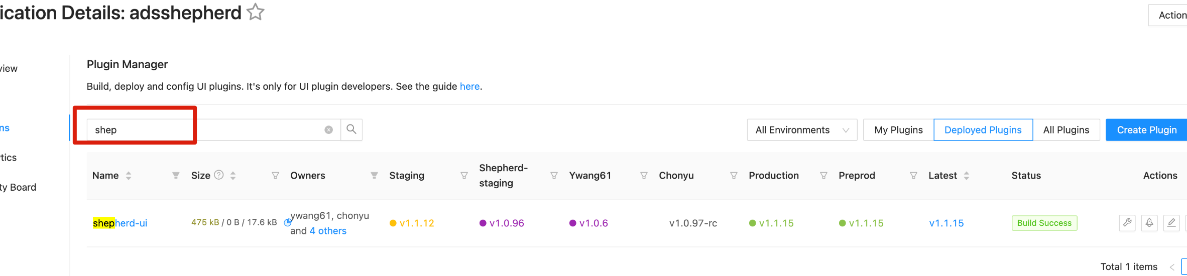

## 2. Trigger a build

* click the 🔧 icon under **Actions** column
* If required "plugin owner" permission appears, please contact Chong Yu (@chonyu).

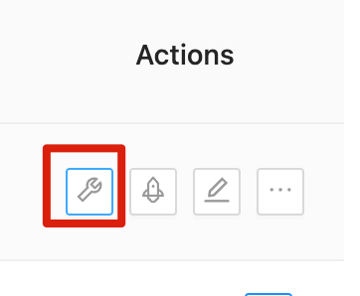

* Check the **Latest version**, **Increment type**, and **Branch to build** should be **master**
  + **tip: if we can't see "master" branch.** It's because too many branches before master, like feature/* delete old branches already merged, or use forked individual repo to file PR

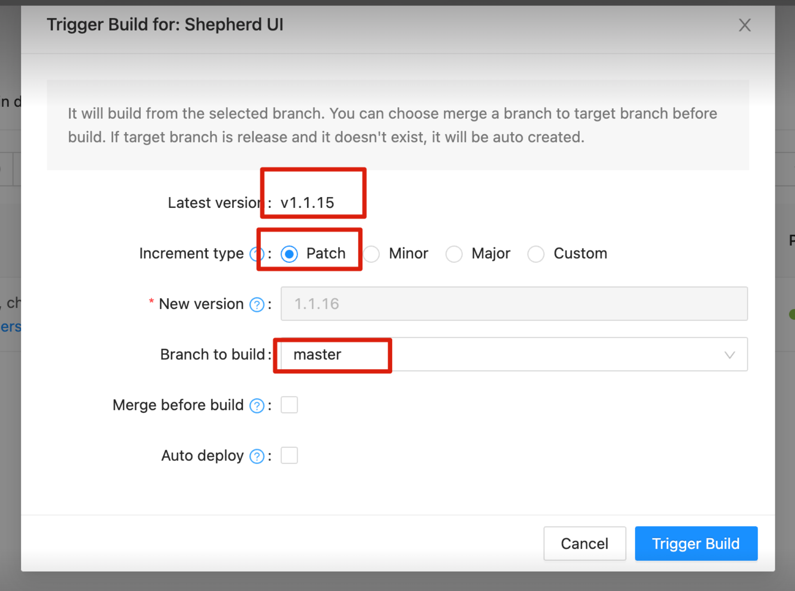

## 3. Deploy the new build (Production or Preprod)

* click the 🚀 icon under **Actions**.

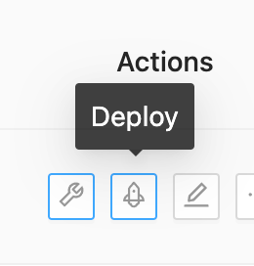

* Select the environment/s

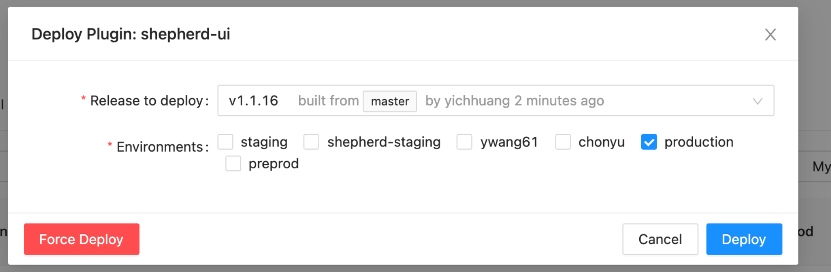

## 4. Verify the deployment result

* check versions on the webpage

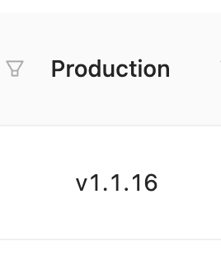

* check the printed versions in the browser's developer tools console

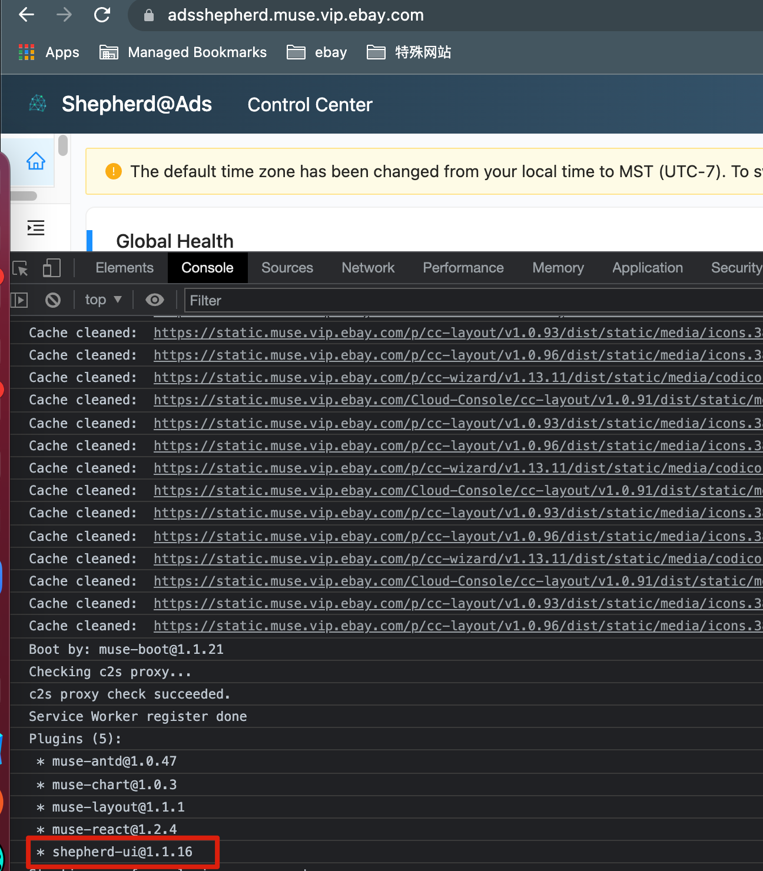

* check new features work or not
* Note: feature owners should check if their new features are working or not

# Shepherd Backend (API & Worker)

## Note: the order of Shepherd backend deployment is worker, beat (if needed) and api.

## 1. Build your image via Jenkins (Prod or Preprod)

* Jenkins project: <http://shepherd.curtistest.svc.130.tess.io:8080/view/Shepherd/job/Shepherd-backend-image-build/>
* Choose the environment.

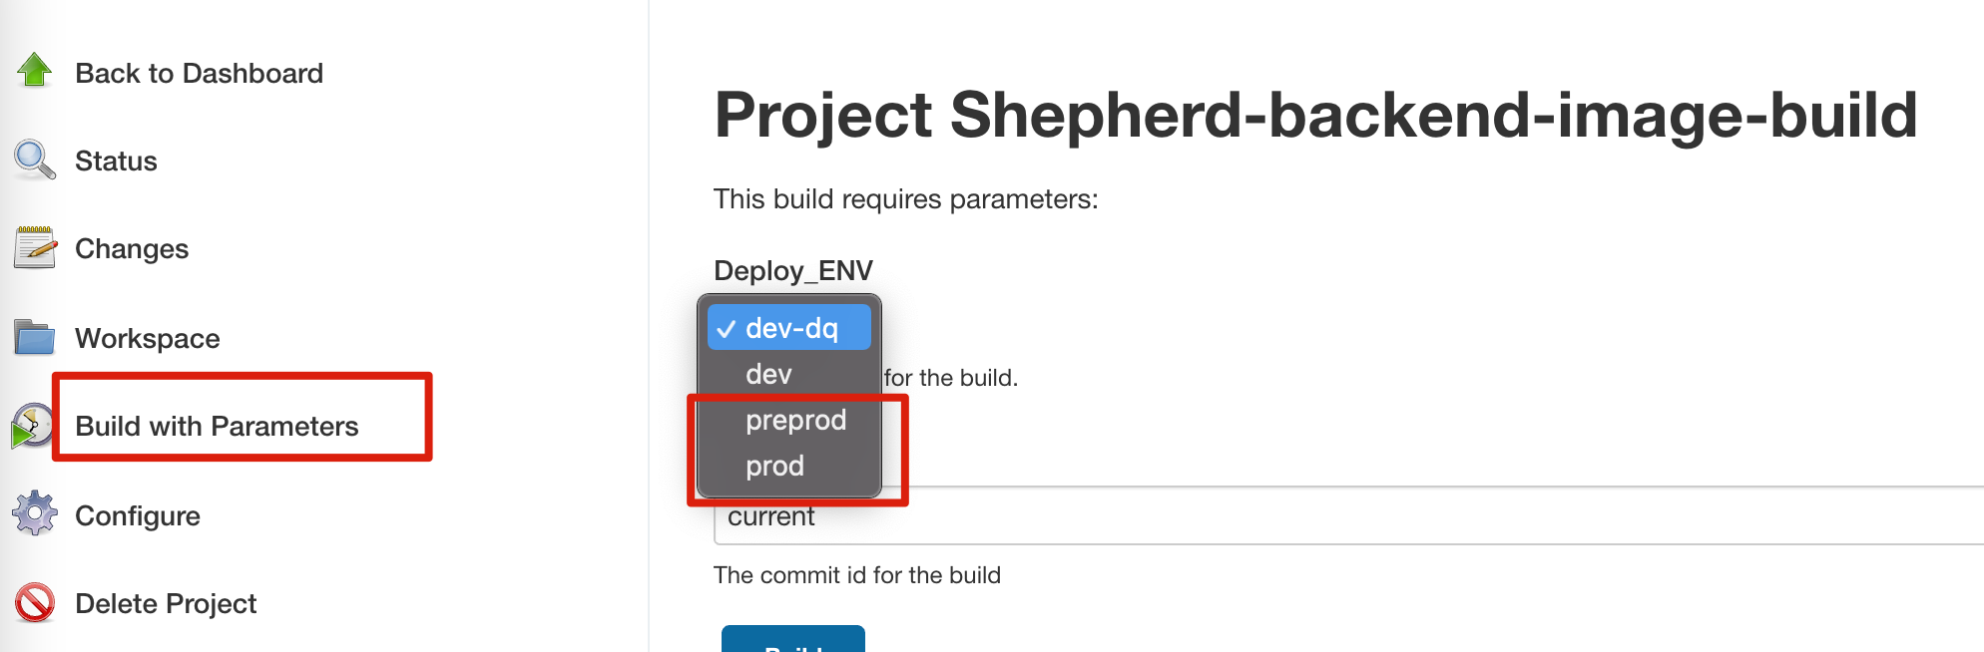

## 2. Verify the image is pushed to the hub

* check the image status here: <https://hub.tess.io/repository/adsccoe/shepherd?tab=tags>
* Note: there should be an image with the version you just built.

## 3. Deploy the image via Cloud Console

* Preprod: <https://cloud.ebay.com/object/detail/ApplicationInstance:dataquality-deployments-prod:fcp-prod:ads-monitoring-prod>
* production: <https://cloud.ebay.com/object/detail/Namespace:shepherd-prod:fcp-prod>
* choose the project you want to deploy:

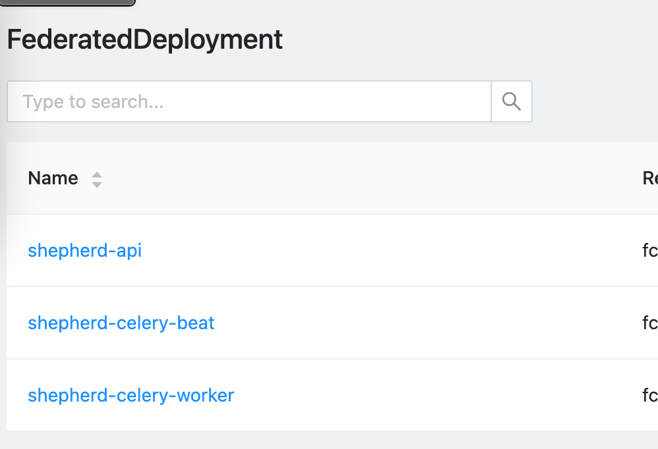

* Note: when deploying shepherd-api,   fountsvc-sidecar does not needed upgrading in most cases
* click **Rollout image**



* choose your image

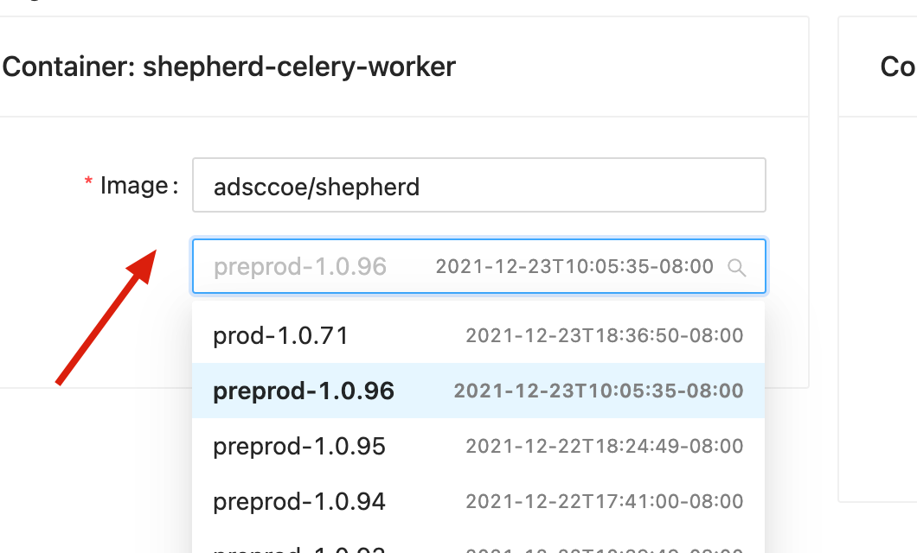

* **use Rollout Strategy: "one by one" policy when deploying Celery Worker**

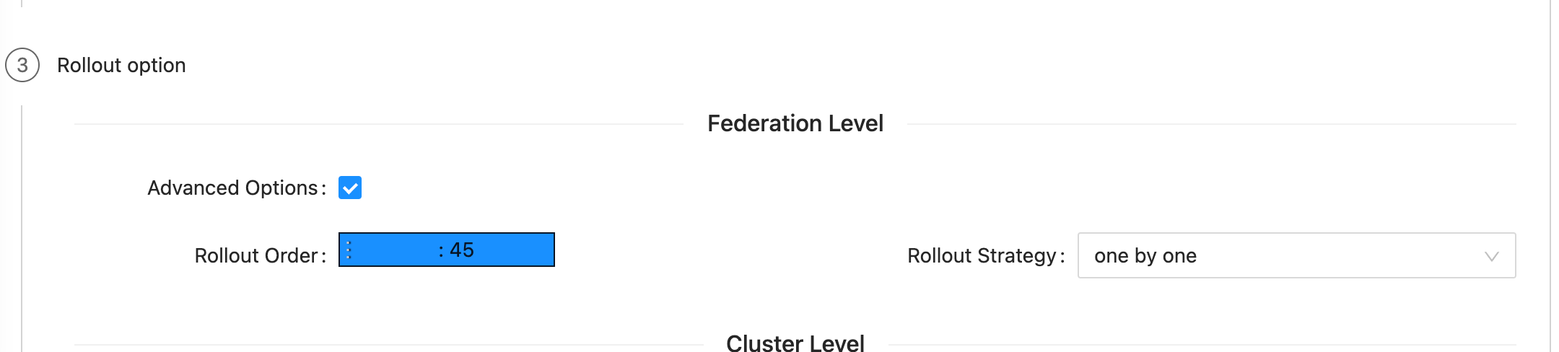

* Note: make sure the first worker (the deployment starts with) has been removed from Celery system before the deployment starts.
* refer to "stop Celery Workers via Flower one by one when deploying Celery Worker(Production Only!)" for how to remove one worker from Celery System

## 4. Start "Dry run" and "Submit"

* **Note: stop Celery Workers via Flower one by one when deploying Celery Worker(Production Only!)**
* Flower: <http://shepherd-api-adsshepherd.vip.ebay.com:5555/>

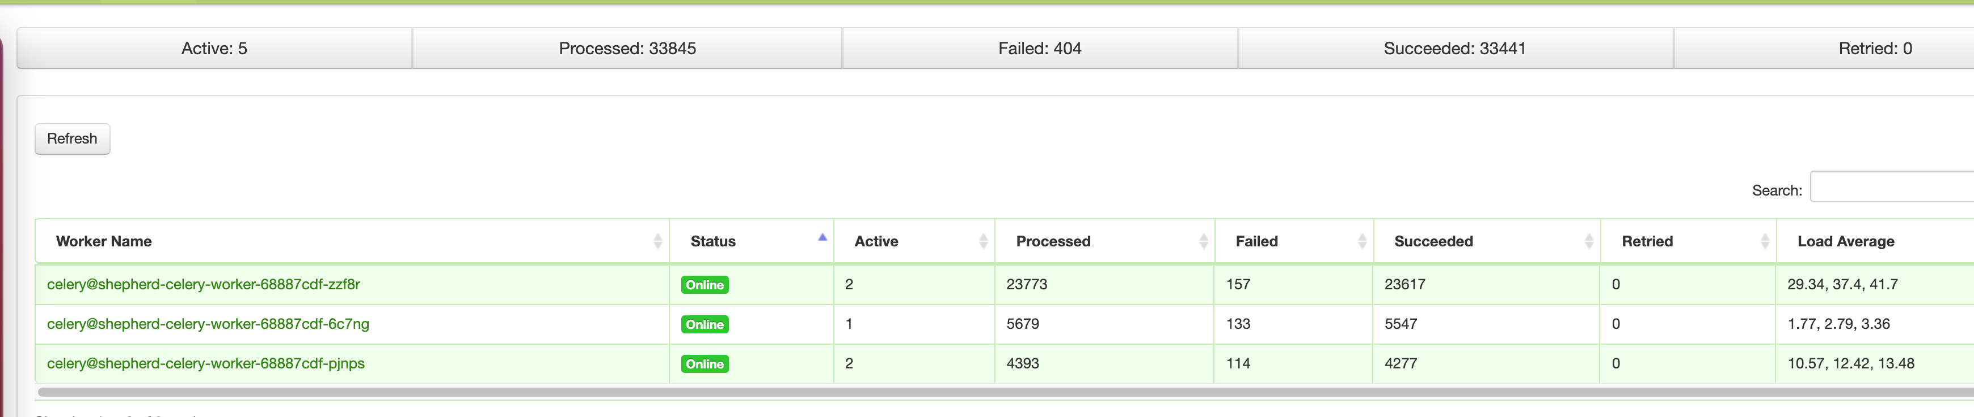

* Remove one of the worker before deploying new image to it and them put it back after finished. Then start for the next worker

### How to remove a worker

* Click the worker
* Go to "Queue" tab
* Click the "Cancel Consumer" button
* Wait for the queue to be empty

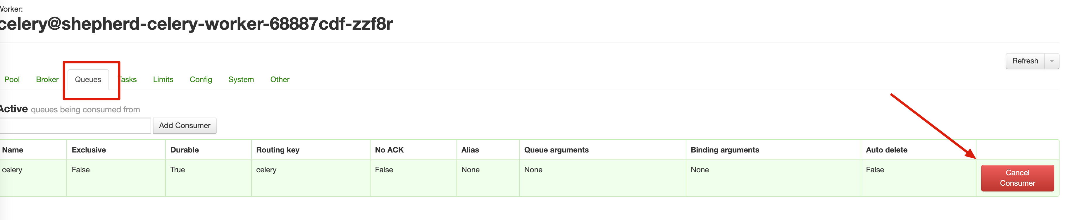

## 5. Check if new features are working or not

* Note: feature owners should check if their new features are working or not

# Shepherd Backend (Beat)

* Note: If no codes changed for celery beat configuration, there is no need to rollout beat image.
* The rollout image steps are as the same as those for api, except one step !!
* We only deployment one Beat on cluster 37 and no other beats on cluster 38 and cluster 40

### How to deploy one Beat on cluster 37

1. Do the same rollout image steps as for API deployment and click the 'submit' button in the rollout image page.
2. You will see the upgrade for pods in cluster 37 is in progress and wait for it to be done.(<https://cloud.ebay.com/object/detail/FederatedDeployment:shepherd-celery-beat:fcp-prod:shepherd-prod>)
3. Then you will see a Resume button in the left top corner in the Rollout table in the page. Please HOLD ON there. (see below snapshot)
4. Please check the image build is upgraded as expected.

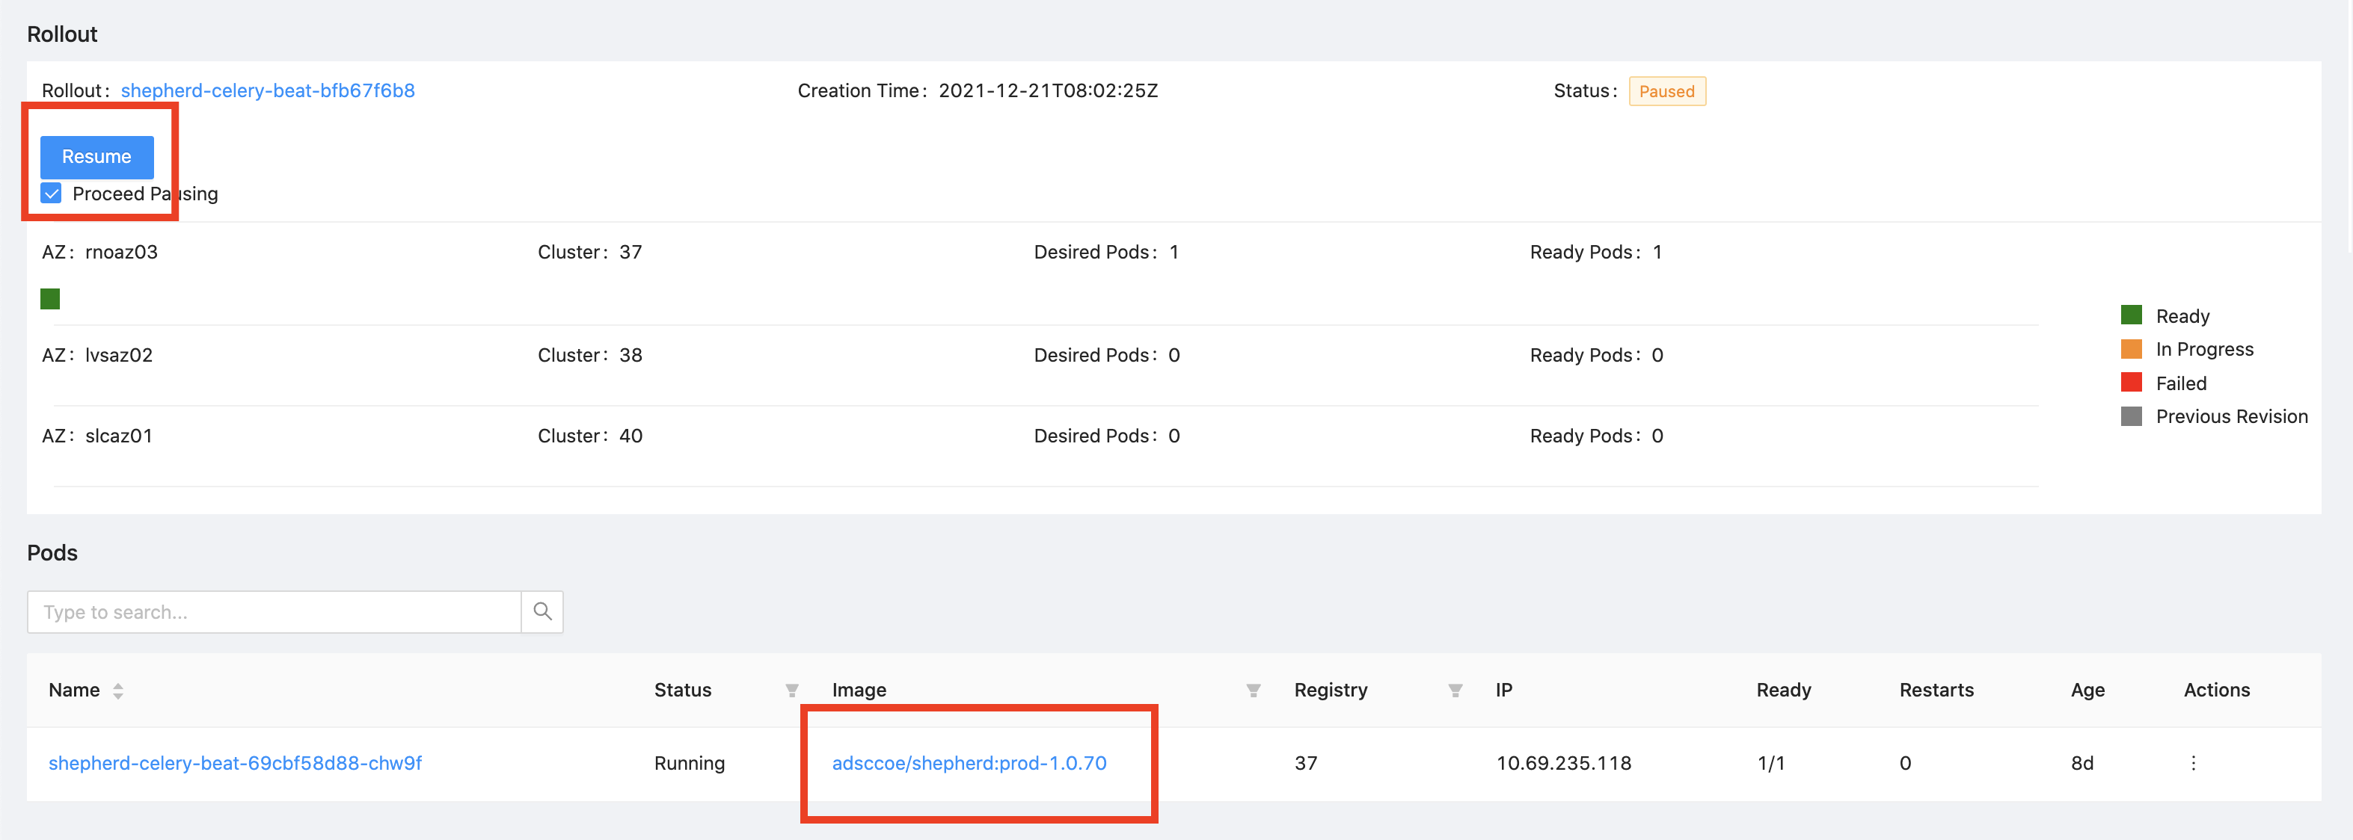

# Deployment on Staging Env to test from unmerged branches

## 1. Purpose and Preparation

* It would be nice for reviewers to test out your feature before approving your PR. Therefore, you may consider deploying your code from a branch to the Staging Environment for others to review and test.
* **You will deploy code from a branch.** Before deployment, create a branch and merge the desired code to that branch of adsinfra/shepherd (backend) or adsinfra/shepherd-ui (frontend).
* Ultimately, your code/new feature will be deployed on the Shepherd Staging environment: <https://adsshepherd.muse.qa.ebay.com/>

## 2. Frontend Deployment for Staging

* Open the Cloud Console Plugin Page for Ads Shepherd: <https://cloud.ebay.com/app/detail/adsshepherd/plugins>
* Search for **shepherd-ui**
* Trigger a build. **Select from your branch that you want to deploy**, do not select master.

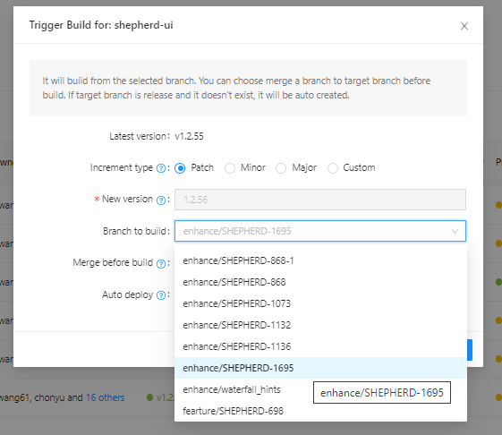

* Deploy the build.  Cick the 🚀 icon under **Actions.** Select "**staging**" under Environments.

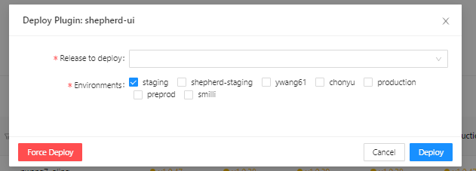

## 3. Backend Deployment for Staging

### Build your image

* Go to Jenkins for Shepherd Backend: <http://shepherd.curtistest.svc.130.tess.io:8080/view/Shepherd/job/Shepherd-backend-image-build/>
* Click "Build with Parameters". You must log into an independent account (not your eBay account) in order to see this button. If you do not have an account, please contact Bingcheng Shao(@binshao).

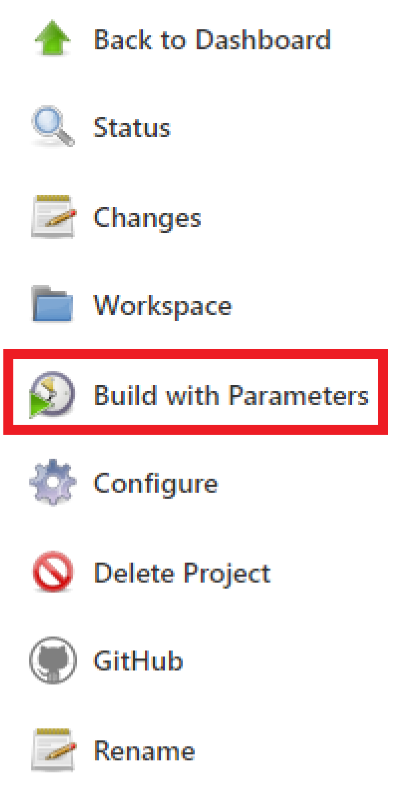

* Select the environment "dev-dq". Input the name of the Shepherd branch that you want to deploy. Then click "Build" to start building.

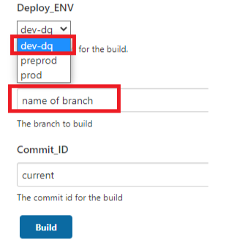

* After building, check the built image for dev environment at <https://hub.tess.io/repository/adsccoe/data-quality?tab=tags>

### Deploy at Worker

* Deployment should be done in sequence of Worker - Beat - Api. Your eBay account must be authorized before rolling out image, please contact Bingcheng Shao(@binshao) for authorization.
* Rollout the image for worker of Staging/Dev environment at <https://cloud.ebay.com/object/detail/FederatedDeployment:data-monitoring-celery-worker-dataquality:fcp:ads-monitoring-dev/summary>
* Click Rollout image on the top right corner.



* Select the image that you want to rollout.

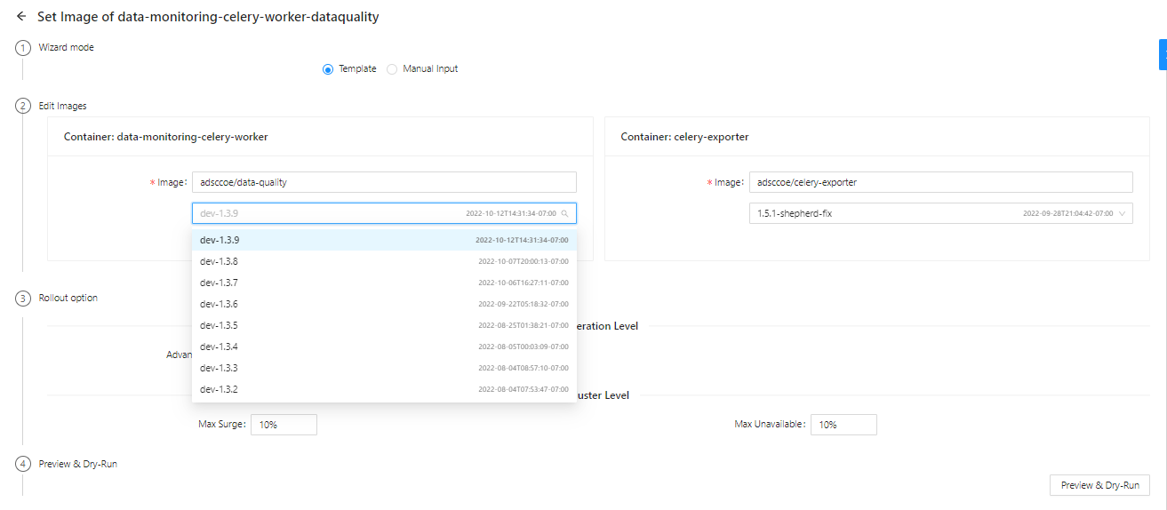

* Click Preview & Dry-Run



* Click Dry-Run



* Click Submit that appeared after the Dry-Run



* You will be directed back to the summary page. You will see the Rollout column appearing similar to below:

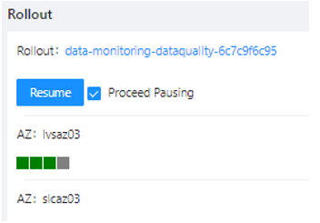

* If there is a Resume button in the image above, click it. The green boxes shows the units to be rolled out. All will be green at the end if no failure occurs. During the rollout, the box may become red temporarily, this means the pod is restarting, which is expected, do not panic.
* Check if the image has been rolled out successfully at the Pods column. If it is rolled out successfully, you should see the right image version.

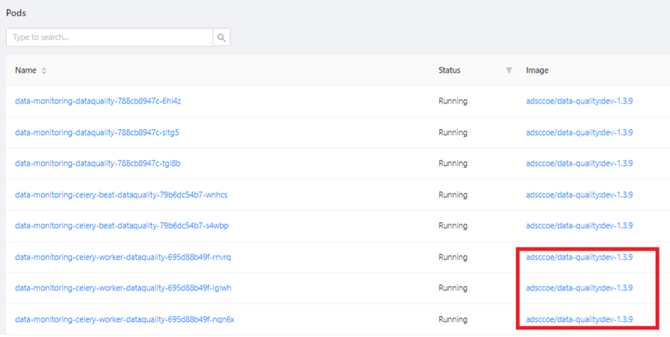

### Deploy at Beat

* Rollout image for Beat of Staging/Dev environment at <https://cloud.ebay.com/object/detail/FederatedDeployment:data-monitoring-celery-beat-dataquality:fcp:ads-monitoring-dev>
* The deployment for Beat follows the same steps as Worker. Except when Resume button appears at the summary page, you have to **click twice, so two pods will be updated**.
* The deployment may fail due to timeout. If so, refresh the page try again the deployment process for Beat.

### Deploy at Api

* Rollout image Api for Staging/Dev environment at <https://cloud.ebay.com/object/detail/FederatedDeployment:data-monitoring-dataquality:fcp:ads-monitoring-dev/summary>
* The deployment for Api follows the same steps as Worker.

## ****4. Testing at Staging****

* After the completion of the above deployment process for Staging/Dev environment, you can test your deployed branches at the Staging environment <https://adsshepherd.muse.qa.ebay.com/>
* To test both frontend and backend changes in Shepherd, please remember to follow deployment steps for **both** frontend and backend deployment.
* The Staging Environment currently may not have sufficient data for some of your code to test through. You may consider uploading data manually to the staging Elastic Search at <https://estess762test-kibanaslc.stratus.qa.ebay.com/app/home#/>

# Update and Send Release Information

* update the release note page
  + <https://github.corp.ebay.com/adssre/shepherd/wiki/Release-Notes>
* send the release info to Slack #Shepherd-dev
  + [Format example](https://ebay-eng.slack.com/archives/C01RP75206Q/p1640318512050400)